**Smoke sensor Circuit using Optocoupler**

**Circuit Diagram:**

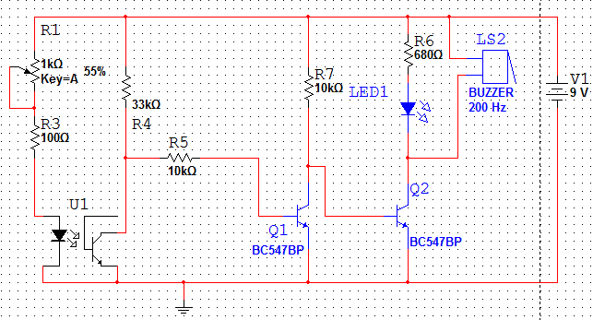

The operation of the circuit is that when the optocoupler detects the smoke then the light from infrared led cannot reach up to photo transistor and phototransistor gets off and as a result the transistor Q1 gets off and the transistor Q2 gets on and Led and buzzer gets on.

When the smoke is not present then the light from IR led reaches properly to the photo transistor and phototransistor gets on and very low voltage reaches up to pin 2 and as a result the transistor Q1 gets on and the transistor Q2 gets off due to this reason the Led and buzzer remain off.

Whole circuit is powered by 9v and the potentiometers are used to change the sensitivity of sensor.

**Design and Calculation of Circuit Components:**

In this circuit optocoupler along with potentiometer to change its sensitivity, two transistors as BC547, Buzzer, Led and some basic components like resistors and capacitors are included. The basic design of the circuit is that voltage coming on the phototransistor of optocoupler is applied on the base of the transistor and on the basis of this value the transistor on or off accordingly and the status of led and buzzer change.

**Calculation for components:**

**LED resistor calculation:**

Forward Voltage drop of an led Vf =2.0V

Forward Current of an led If=20mA

Input voltage =9V

As we know that

Input voltage=IR

Vin-IfR1-2=0

9-20mA*R1-2=0

R1=7/20mA

R=350ohms

Due to this reason we have used 350ohm resistor with Led.

**Calculation for Resistor at Collector of Q1:**

Vcc=IcRc

Rc=Vcc/Ic

As current is 900uA so

Rc=9/900uA

Rc=10k

**Calculation for Resistor at base of Q1:**

VBB=IBRB – VBB

9=723.07mA*Rb-0.7

Rb=10.4k

So due to this reason we have used 10k resistor.

**Selecting Commercial Components:**

Commercially the opotocoupler used is the named as MOC7811 which comes in the form of an IC having pins and it contains the IR led and phototransistor built in the form of IC. The datasheet of this is attached.

For using potentiometer we can use any type of it which depend on our need and circuit design.

For using buzzer any kind of buzzer can be attached both 5V and 9v buzzer are present in the market.

Similarly the transistor which is used in the circuit is the BC547 is also available commercially having three pins one for collector other for emitter and center pins is for base.

Similarly the resistors and capacitor sheets are available commercially as per our circuit requirement.

The other thing which is battery can also be found commercially as our desire.

**When No smoke is present:**

Node1---------voltage across optocoupler

Node2---------voltage across phototransistor

Node3---------voltage at base of 1St Transistor

Node4---------voltage at base of 2nd Transistor

Node5---------voltage at collector of transistor2 (at Led cathode)

Branch1------- current at optocoupler terminal

Branch2------- current between phototransistor and 1st transistor

Branch3------- current at base of 2nd transistor

Branch4------- current at transistor2 base

**Voltage at nodes:**

|  |  |  |  |  |
| --- | --- | --- | --- | --- |
|  | Node1 | Node2 | Node3 | Node4 |
| Voltages | 744.1mv | 2.13v | -19.75mv | 7.706mv |

**Current at branches:**

|  |  |  |  |
| --- | --- | --- | --- |
|  | Branch1 | Branch2 | Branch3 |
| current | 16.5mA | 147.303uA | 1.14nA |

**When smoke is present:**

Node1---------voltage across optocoupler

Node2---------voltage across phototransistor

Node3---------voltage at base of 1St Transistor

Node4---------voltage at base of 2nd Transistor

Node5---------voltage at collector of transistor2 (at Led cathode)

Branch1------- current at optocoupler terminal

Branch2------- current between phototransistor and 1st transistor

Branch3------- current at base of 2nd transistor

Branch4------- current at transistor2 base

**Voltage at nodes:**

|  |  |  |  |  |
| --- | --- | --- | --- | --- |
|  | Node1 | Node2 | Node3 | Node4 |
| Voltages | 753.9mv | 18.17mv | 831.4mv | 174.4uv |

**Current at branches:**

|  |  |  |  |
| --- | --- | --- | --- |
|  | Branch1 | Branch2 | Branch3 |
| current | 20.6mA | 0A | 816.8mA |